

**Tech Saksham**

**Case study Report**

**Data Analytics with Power BI**

**“Analysis of Commercial**

**Electrical Consumption in India”**

**“**APC Mahalaxmi college for women”

|  |  |
| --- | --- |
| **NM ID** | **NAME** |
| **9416F53FF451CD385F5488591B7DDE94** | **P.Krishna kayathri** |

|  |  |
| --- | --- |
| R.UMAMAHESHWARI | Trainer Name |
| R.UMAMAHESHWARI | Master Trainer |



**ABSTRACT**

The real-time electricity price is constantly changing, so it must be estimated from grid data associated with it. Furthermore, there are often some variations in the actual power consumption of appliances due to the uncertainty of human behavior, the characteristics of appliances, and the influence of the environment. In addition, when optimizing, serious problems such as tripping and circuit overload must be taken into account. Therefore, considering random electricity prices and random electricity consumption, in the paper, we present the models to simulate real-time changes in electricity prices and energy consumption behaviors, as well as a method to help users optimize their use of household appliances and quantify their requirements with lower electricity cost. By analyzing the experimental results, we demonstrate that our work can be used to provide a scheduling scheme for appliances that minimizes electricity costs and reduces grid pressure.



**INDEX**

|  |  |  |
| --- | --- | --- |
| **Sr. No.** | **Table of Contents** | **Page No.** |
| 1 | Chapter 1: Introduction | 4 |
| 2 | Chapter 2: Services and Tools Required | 6 |
| 3 | Chapter 3: Project Architecture | 7 |
| 4 | Chapter 4: Modeling and Result | 9 |
| 5 | Conclusion | 18 |
| 6 | Future Scope | 19 |
| 7 | References | 20 |
| 8 | Links | 21 |



**CHAPTER 1**

**INTRODUCTION**

* **Problem Statement**

Now a days, humans have a greater influence on energy consumption in residential buildings than other types of buildings. Although existing studies focus on how energy consumption is affected by building technologies and occupant demographics, few studies have incorporated the impact of occupant energy use patterns. The goal of this study is to identify the features that affect energy consumption in residential buildings and to measure their predictive performance. The researchers examined the impact of occupants’ energy use behaviors and the energy use patterns of home appliances on home energy consumption.

* **Proposed Solution**

Electricity is an essential resource for a thriving life. It runs our daily life. Life without electricity would be impossible to imagine now. We generate electricity using coal or natural gas. However, people do not realize the natural resources to do as are limited and non-renewable. We must conserve electricity so that we can conserve these resources.In other words, electricity serves mankind greatly. We must stop the wastage of power. The world will lose its light if there is no electricity.



**Feature**

Data from the Residential Energy Consumption Survey (RECS) are analyzed to select features for prediction, using multiple machine learning algorithms including support vector machine (SVM) and random forest. The results provide a list of features that efficiently predict energy consumption in residential buildings. The selected 32 features achieve 98% of the prediction performance of that from the entire 271 features. This list of effective features can be used to improve the effectiveness of energy saving programs and to educate occupants about their energy use patterns.

* **Advantages**

**Easy to manage and transport:**

With proper planning or management, electricity transmission is possible on a large scale over a long distance

**Easily accessible and produced**

Using a wide variety of renewable and non-renewable source of energy in producing electricity make it easy to assemble. Everyone can access electricity.

**Reduces greenhouse emission**

Electricity can be produced via renewable energy sources such as wind and solar, which are much cleaner and environmentally friendly.



**Scope**

all of us must understand that even a small step will go a very long way in saving electricity. For instance, if every person at each home switches on the fan when not in use, thousands of watts of electricity can be saved.Similarly, if we use our air conditioners, heaters, ovens, refrigerators and more properly, we can successfully save large amounts of electricity.Furthermore, try making use of natural light more. Do not keep the lights unnecessarily in the morning and afternoons. Make do with the natural light as it is enough. We must replace all our old appliances as they consume a lot of electricity. In other words, we must strive to make our homes energy efficient.Moreover, always remember to unplug your electrical gadgets when not in use. These devices consume at least 10% of electricity even when inactive. Thus, unplug them to save electricity. The researchers examined the impact of occupants’ energy use behaviors and the energy use patterns of home appliances on home energy consumption.



**CHAPTER 2**

**SERVICES AND TOOLS REQUIRED**

**2.1 Services Used**

* **Data Collection and Storage Services**: Banks need to collect and store customer data in real-time. This could be achieved through services like Azure Data Factory, Azure Event Hubs, or AWS Kinesis for real-time data collection, and Azure SQL Database or AWS RDS for data storage.
* **Data Processing Services**: Services like Azure Stream Analytics or AWS Kinesis Data Analytics can be used to process the real-time data.
* **Machine Learning Services**: Azure Machine Learning or AWS SageMaker can be used to build predictive models based on historical data.

**2.2 Tools and Software used**

**Tools**:

* **PowerBI**: The main tool for this project is PowerBI, which will be used to create interactive dashboards for real-time data visualization.
* **Power Query**: This is a data connection technology that enables you to discover, connect, combine, and refine data across a wide variety of sources.



**Software Requirements**:

* **PowerBI Desktop**: This is a Windows application that you can use to create reports and publish them to PowerBI.
* **PowerBI Service**: This is an online SaaS (Software as a Service) service that you use to publish reports, create new dashboards, and share insights.

**PowerBI Mobile**: This is a mobile application that you can use to access your reports and dashboards on the go



**CHAPTER 3**

**PROJECT ARCHITECTURE**

**3.1 Architecture**

**USER**  **FRONTEND**  **BACKEND**

 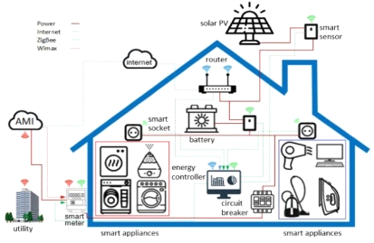 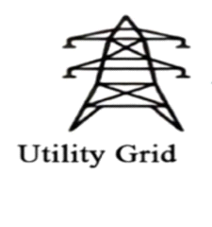

Here’s a high-level architecture for the project:

* **Data Collection**: Real-time customer data is collected from various sources like bank transactions, customer interactions, etc. This could be achieved using services like Azure Event Hubs or AWS Kinesis.
* **Data Storage**: The collected data is stored in a database for processing. Azure SQL Database or AWS RDS can be used for this purpose.
* **Data Processing**: The stored data is processed in real-time using services like Azure Stream Analytics or AWS Kinesis Data Analytics.



* **Machine Learning**: Predictive models are built based on processed data using Azure Machine Learning or AWS SageMaker. These models can help in predicting customer behavior, detecting fraud, etc.
* **Data Visualization**: The processed data and the results from the predictive models are visualized in real-time using PowerBI. PowerBI allows you to create interactive dashboards that can provide valuable insights into the data.
* **Data Access**: The dashboards created in PowerBI can be accessed through PowerBI Desktop, PowerBI Service (online), and PowerBI Mobile.

This architecture provides a comprehensive solution for real-time analysis of bank customers. However, it’s important to note that the specific architecture may vary depending on the bank’s existing infrastructure, specific requirements, and budget. It’s also important to ensure that all tools and services comply with relevant data.



**CHAPTER 4**

**MODELING AND RESULT**

**Manage relationship**

The “disp” file will be used as the main connector as it contains most key identifier (account id, client id and disp id) which can be use to relates the 8 data files together. The “district” file is use to link the client profile geographically with “district id”

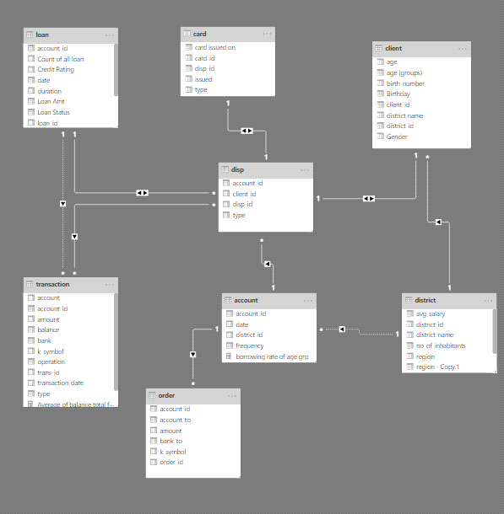



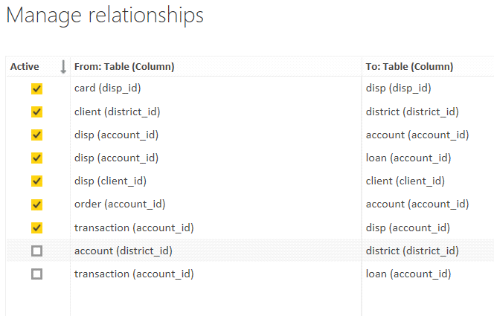



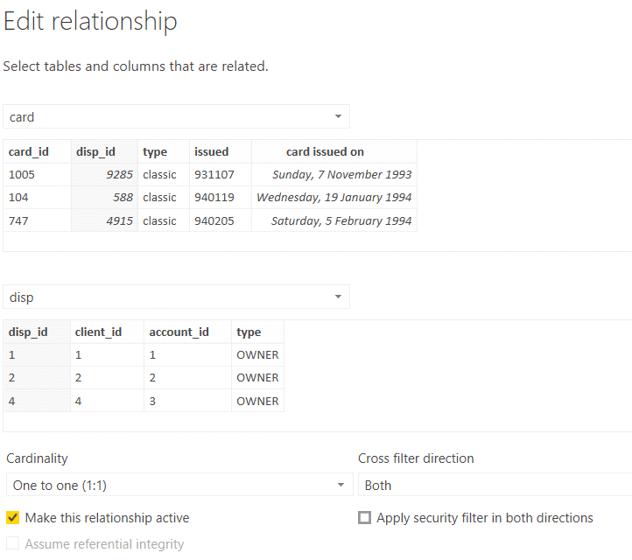



**Replacing values**

Set some fields to English for easy understanding, we replace values to English with the Power Query Editor.

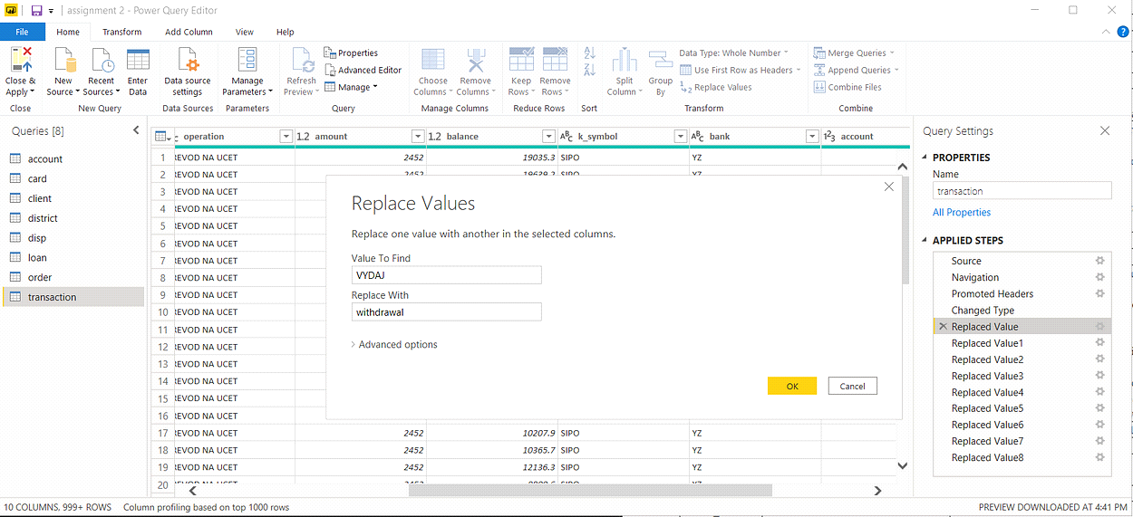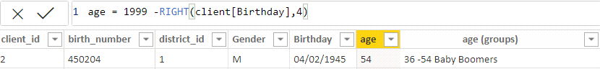





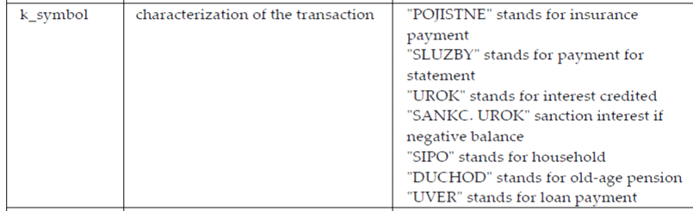

Changing the order of Region name at Power Query

Duplicate the “district /region” then split column using space as delimiter.

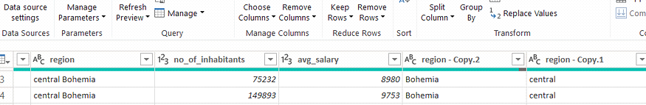

Then merge column by Region and direction. Refer to applied steps for details.

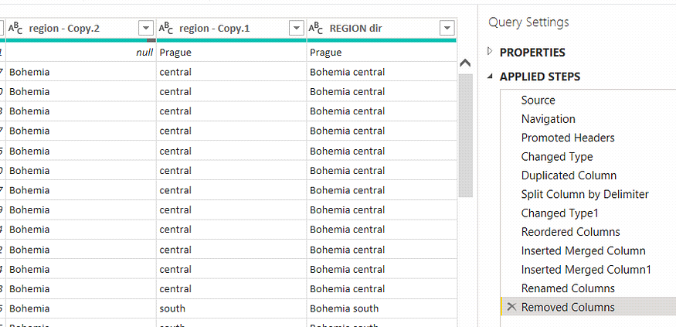



**Credit Rating and Loan Status**

As the Loan status uses A, B, C, D which are not reader friendly. We can add a column to represent what it stands for, we also simplify the classification of those with late or default on payment as bad credit, refer to the table below for details on the new columns added.

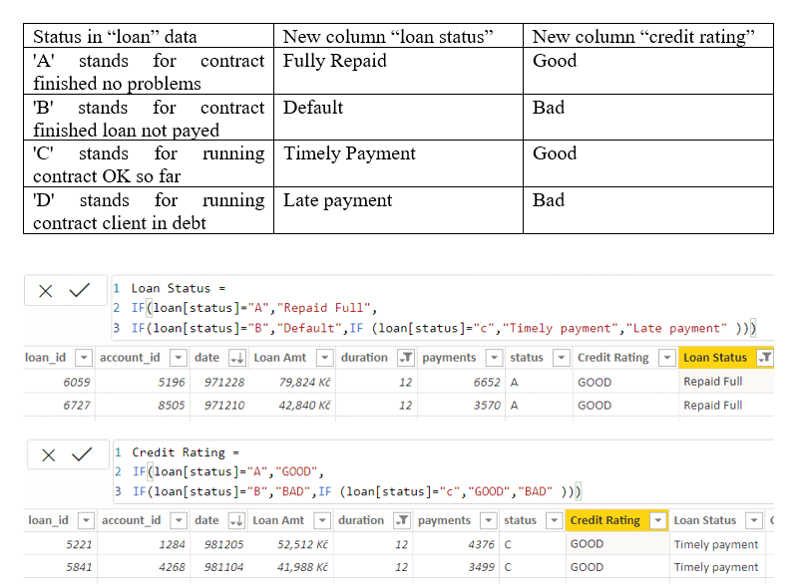



**Dashboard**

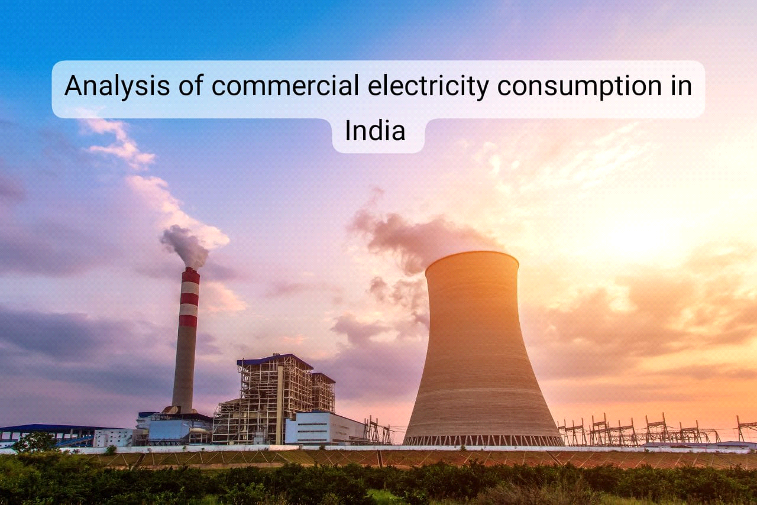

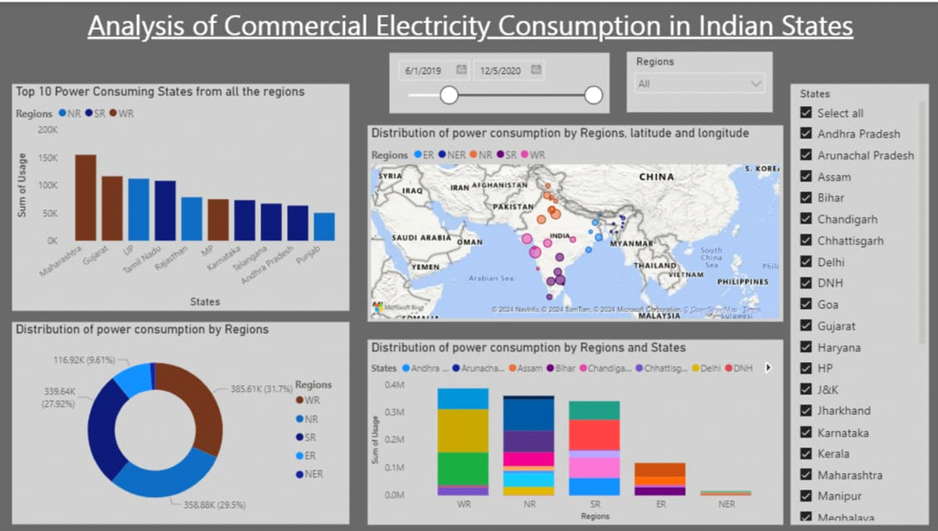



**CONCLUSION**

Electricity is a second source of energy that can be received from the conversion of another energy source, such as natural gas, nuclear power, coal, and other natural resources. Electricity is a basic part of nature, one of our most widely used forms of energy. Energy Efficiency covers wide-ranging topics related to energy efficiency, energy savings, energy consumption, energy sufficiency, and energy transition in all sectors across the globe. Coverage includes energy efficiency policies at all levels of governance enabling social, organizational, and economic factors of sufficient and efficient behavior and decisions; analysis and modeling of energy efficiency performance, measures, policies, outcomes, and impacts; energy management systems and energy services; the role of energy efficiency and demand-side management in energy planning, energy markets and risk assessment; local sustainable energy planning; energy behavior; acceptability of policy, technology, and new energy systems; and emerging technologies and approaches to improve energy consumption.



**FUTURE SCOPE**

**India is the world’s third-largest energy consuming country, thanks to rising incomes and improving standards of living. Energy use has doubled since 2000, with 80% of demand still being met by coal, oil and solid biomass. On a per capita basis, India’s energy use and emissions are less than half the world average, as are other key indicators such as vehicle ownership, steel and cement output. As India recovers from a Covid-induced slump in 2020, it is re-entering a very dynamic period in its energy development. Over the coming years, millions of Indian households are set to buy new appliances, air conditioning units and vehicles. India will soon become the world’s most populous country, adding the equivalent of a city the size of Los Angeles to its urban population each year. To meet growth in electricity demand over the next twenty years, India will need to add a power system the size of the European Union to what it has now.**



**REFERENCES**

<https://medium.com/analytics-vidhya/analysis-of-bank-customers-using-dashboard-in-power-bi-a366f2b3e563>

**LINK**